**EXPERIMENT NO: -1**

**Aim: -** To perform python matrix multiplication. Discuss the complexity of algorithm used.

NAME: -Nishant Bhandari

CLASS: - SYCS

ROLL NO: - 06

SUBJECT: - Fundamentals of Algorithm.

SIGN: -

**Aim: -** To perform python matrix multiplication. Discuss the complexity of algorithm used.

**Source Code: -**

def print_matrix(matrix):

for i in range(len(matrix)):

for j in range(len(matrix[0])):

print("\t",matrix[i][j],end=" ")

print("\n")

def main():

m = int( input("enter first matrix rows"));

n = int( input("enter first matrix columns"));

p = int( input("enter second matrix rows"));

q = int( input("enter second matrix columns"));

if( n != p):

print ("matrice multipilication not possible...");

exit();

#declaration of arrays

array1=[[0 for j in range (0 , n)] for i in range (0 , m)]

array2=[[0 for j in range (0 , q)] for i in range (0 , p)]

result=[[0 for j in range (0 , q)] for i in range (0 , m)]

#taking input from user

print ("enter first matrix elements:" )

for i in range(0 , m):

for j in range(0 , n):

array1[i][j]=int (input("enter element"))

print ("enter second matrix elements:")

for i in range(0 , p):

for j in range(0 , q):

array2[i][j]=int(input("enter element"))

print ("first matrix")

print_matrix(array1)

print ("second matrix")

print_matrix(array2)

#for multiplication

# i will run throgh each row of matrix1

for i in range(0 , m):

# j will run through each column of matrix 2

for j in range(0 , q):

# k will run throguh each row of matrix 2

for k in range(0 , n):

result[i][j] += array1[i][k] * array2[k][j]

#printing result

print ( "multiplication of two matrices:" )

print_matrix(result)

main()

**Input: -**

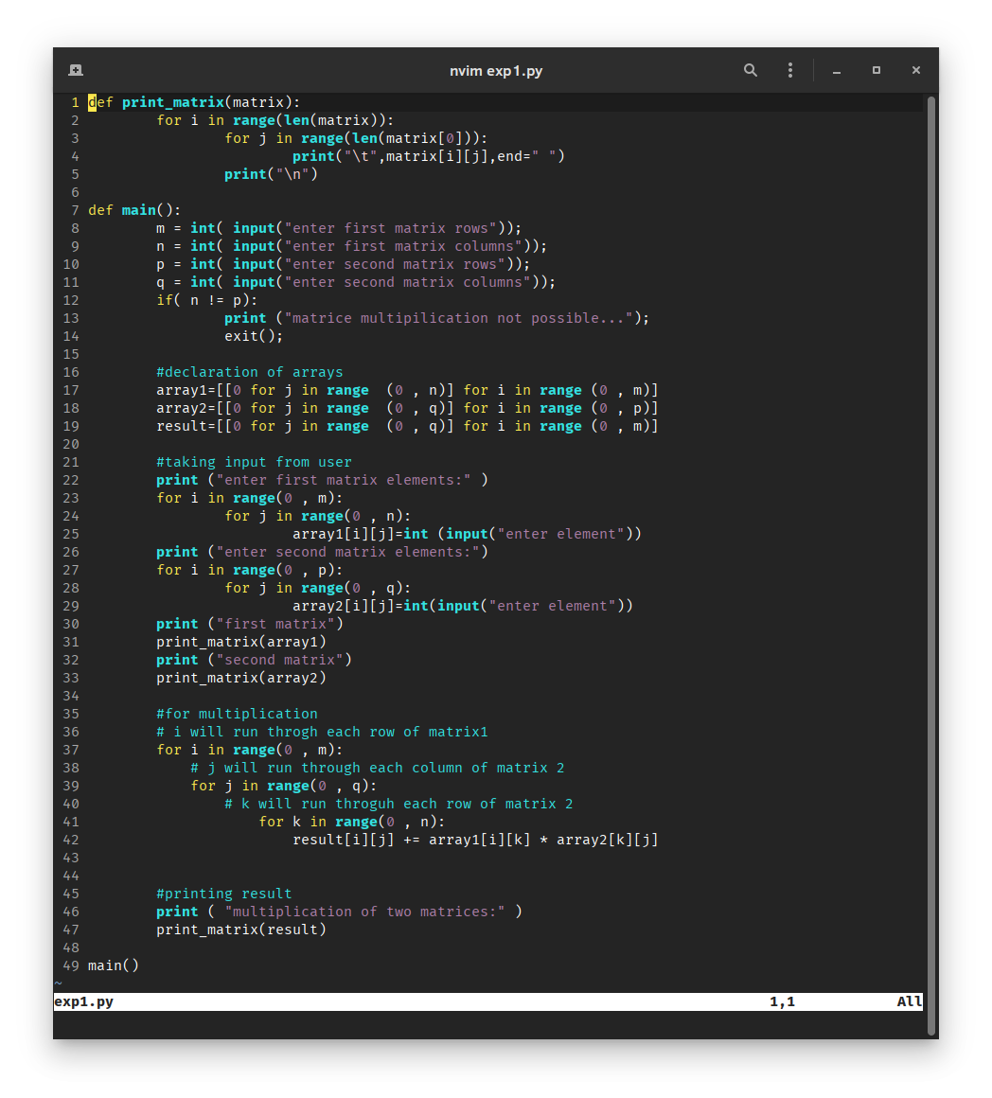

**Output: -**

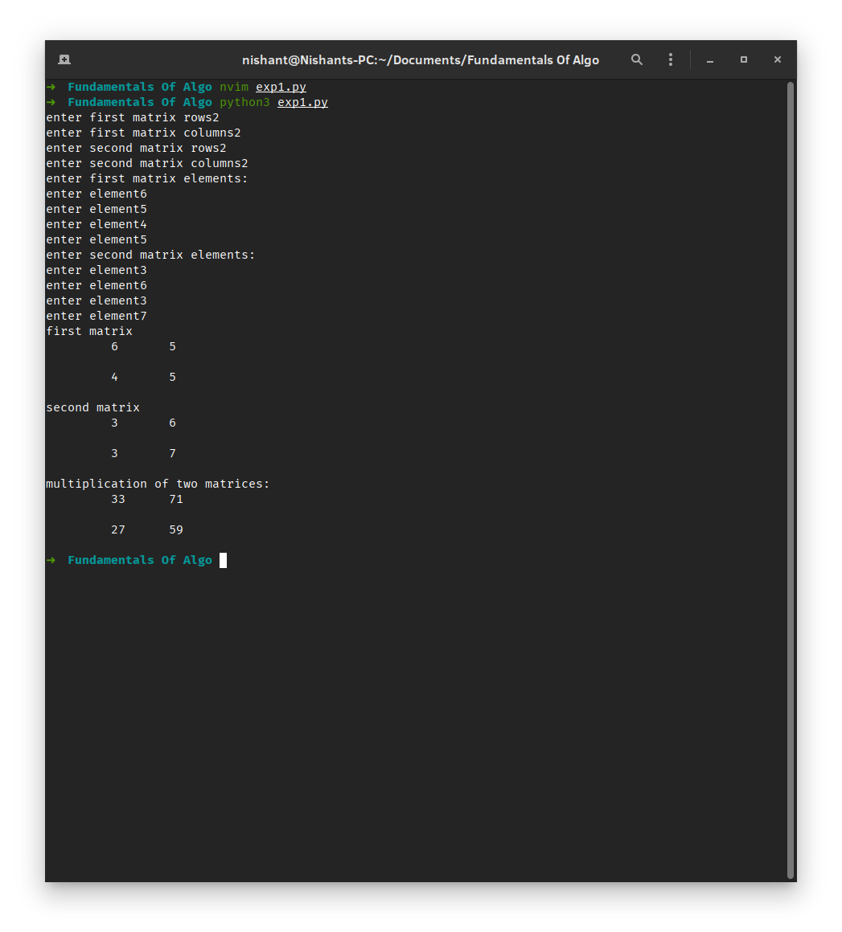CONCLUSION:-

Time Complexity of the given algorithm would be : O(n^3)

Space Complexity of the given algorithm would be : O(n^3)

Thus we studied to perform python matrix multiplication and the complexity of algorithm used.